# **Name: Abdurrahman Qureshi**

# **Roll No: 210451**

Practical No: 10

**1)** **Write a program to generate KeyEvent when a key is pressed and display “KeyPressed” message**

**CODE:**

import javax.swing.*;  
import java.awt.*;  
import java.awt.event.KeyAdapter;  
import java.awt.event.KeyEvent;  
import java.awt.event.KeyListener;

public class Main {  
 public Main() {  
 JFrame frame = new JFrame("My Key Events");  
frame.setBackground(Color.*DARK_GRAY*); frame.setForeground(Color.*WHITE*);   
 Panel P = new Panel();  
P.setBackground(Color.*DARK_GRAY*);  
 P.setForeground(Color.*WHITE*);   
 JLabel label = new JLabel("Press a key");  
 label.setForeground(Color.*WHITE*);   
 Font customFont = new Font(label.getFont().getName(), Font.*PLAIN*, 50);  
 label.setFont(customFont);   
 P.add(label);  
 KeyListener keyListener = new KeyAdapter() {  
 @Override  
 public void keyPressed(KeyEvent e) {  
 label.setText("Key Pressed");}  
 @Override  
 public void keyReleased(KeyEvent e) {  
 label.setText("Press a key");  
 }};  
 frame.add(P);   
frame.addKeyListener(keyListener);   
 frame.setSize(400, 300); frame.setDefaultCloseOperation(JFrame.*EXIT_ON_CLOSE*);  
 frame.setVisible(true); }  
 public static void main(String[] args) {  
 new Main();}}

**OUTPUT:**

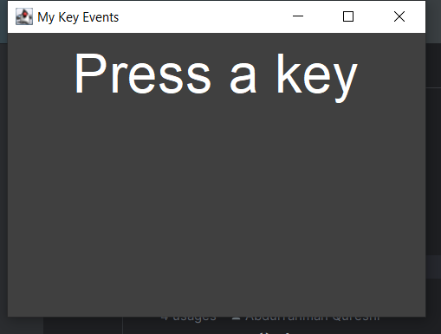 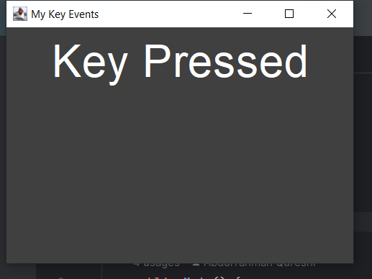

**2)** **Develop a program which will implement special keys such as function keys and arrow keys.**

**CODE:**

import javax.swing.*;  
import java.awt.*;  
import java.awt.event.KeyAdapter;  
import java.awt.event.KeyEvent;  
import java.awt.event.KeyListener;  
import java.awt.event.*;  
  
public class Main {  
 public Main() {  
 JFrame frame = new JFrame("My Key Events");  
frame.setBackground(Color.*DARK_GRAY*); frame.setForeground(Color.*WHITE*);

Panel P = new Panel();  
P.setBackground(Color.*DARK_GRAY*);  
 P.setForeground(Color.*WHITE*);

JLabel label = new JLabel("Press a key");  
label.setForeground(Color.*WHITE*);   
 Font customFont = new Font(label.getFont().getName(), Font.*PLAIN*, 20);  
 label.setFont(customFont);   
 P.add(label);

KeyListener keyListener = new KeyAdapter() {  
 @Override  
 public void keyPressed(KeyEvent e) {  
 int keyCode = e.getKeyCode();  
 String keyText = KeyEvent.*getKeyText*(keyCode);  
 if (isFunctionKey(keyCode)) {  
 label.setText("Function Key Pressed: " + keyText + "\n");  
 } else if (keyCode == KeyEvent.*VK_UP*) {  
 label.setText("Up Arrow Key Pressed\n");  
 } else if (keyCode == KeyEvent.*VK_DOWN*) {  
 label.setText("Down Arrow Key Pressed\n");  
 } else if (keyCode == KeyEvent.*VK_LEFT*) {  
 label.setText("Left Arrow Key Pressed\n");  
 } else if (keyCode == KeyEvent.*VK_RIGHT*) {  
 label.setText("Right Arrow Key Pressed\n");  
 }}};

frame.add(P);   
frame.addKeyListener(keyListener);   
 frame.setSize(400, 300);  
 frame.setDefaultCloseOperation(JFrame.*EXIT_ON_CLOSE*);  
 frame.setVisible(true);

}

private boolean isFunctionKey(int keyCode) {  
 return keyCode >= KeyEvent.*VK_F1* && keyCode <= KeyEvent.*VK_F24*; }

public static void main(String[] args) {  
 new Main();}  
}

**OUTPUT:**

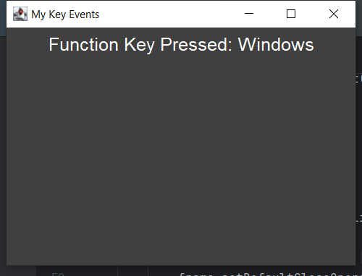 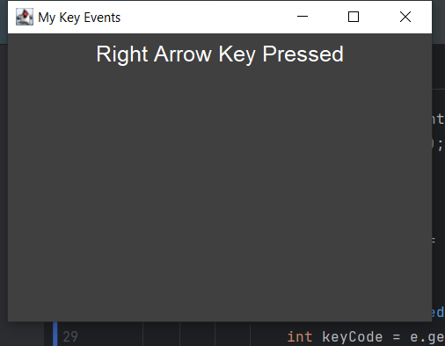 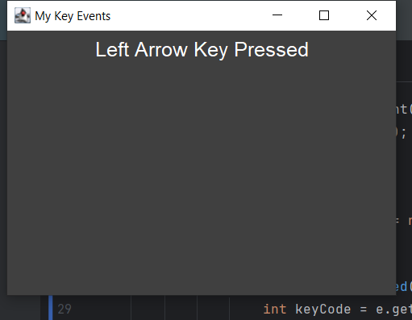 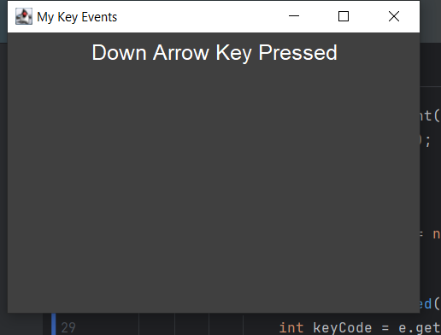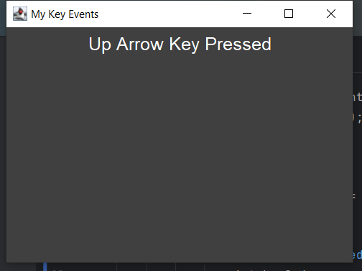

**3)** **Develop a program to accept two numbers and display product of two numbers when user pressed “Multiply” button**

**CODE:**

import javax.swing.*;  
import java.awt.*;  
import java.awt.event.KeyAdapter;  
import java.awt.event.KeyEvent;  
import java.awt.event.KeyListener;  
import java.awt.event.*;  
  
public class Main {  
  
 public Main() {  
 JFrame frame = new JFrame("My Key Events");  
 frame.setBackground(Color.*DARK_GRAY*);  
 frame.setForeground(Color.*WHITE*);  
 frame.setLayout(new BorderLayout());  
  
 JPanel P = new JPanel();  
 P.setLayout(new FlowLayout());  
  
 JLabel label1 = new JLabel("Number 1:");  
 JTextField n1 = new JTextField(10);  
  
 JLabel label2 = new JLabel("Number 2:");  
 JTextField n2 = new JTextField(10);  
  
 JPanel buttonPanel = new JPanel();  
 JButton btn = new JButton("Multiply");  
  
 buttonPanel.add(btn);  
  
 JLabel rLabel = new JLabel();  
  
 btn.addActionListener(new ActionListener() {  
 @Override  
 public void actionPerformed(ActionEvent e) {  
 try {  
 double num1 = Double.*parseDouble*(n1.getText());  
 double num2 = Double.*parseDouble*(n2.getText());  
 double product = num1 * num2;  
 rLabel.setText("Product: " + product);  
 } catch (NumberFormatException ex) {  
 rLabel.setText("Invalid input. Please enter valid numbers.");  
 }  
 }  
 });  
  
 P.add(label1);  
 P.add(n1);  
 P.add(label2);  
 P.add(n2);  
  
 frame.add(P, BorderLayout.*NORTH*);  
 frame.add(buttonPanel, BorderLayout.*CENTER*);  
 frame.add(rLabel, BorderLayout.*SOUTH*);  
 frame.setSize(400, 300);  
 frame.setDefaultCloseOperation(JFrame.*EXIT_ON_CLOSE*);  
 frame.setVisible(true);  
  
 }  
  
 public static void main(String[] args) {  
 new Main();  
 }  
}

**OUTPUT:**

